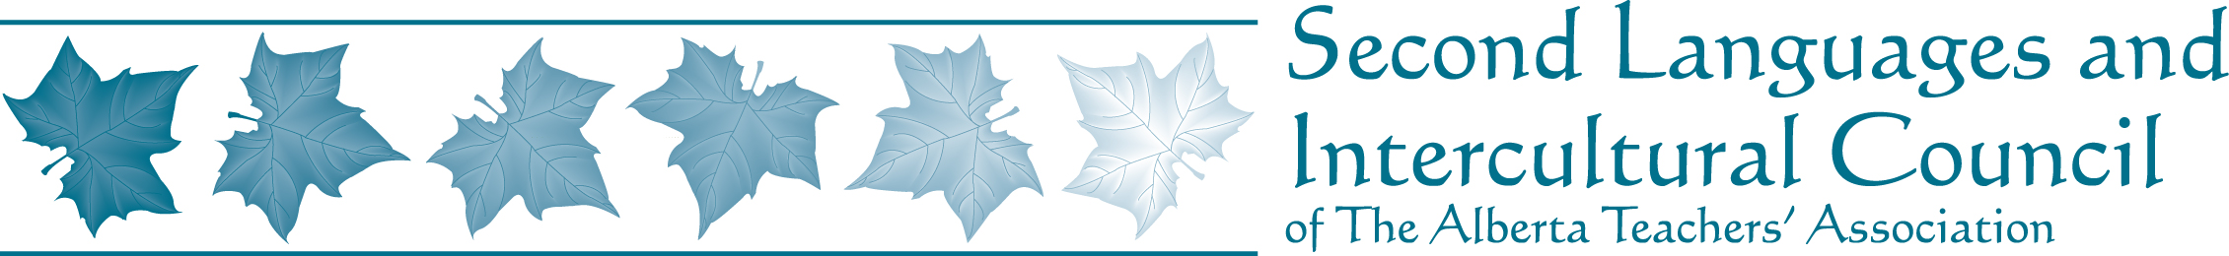

Alberta Spanish Teacher Association

May 15, 2010

Executive News
- Flyers for the Alberta Spanish Teachers Association printed and handed out at the 2nd Languages Matter PD Day
- Alberta Spanish Teacher Association website launched at the end of March, 2010
- Biography posted on the SLIC and ATA website in March, 2010
- Alberta Spanish teachers contacted with letter of introduction, survey, and information on membership
- 5 new Spanish members to SLIC
- Google Group launched, currently with 2 additional members
- Spanish Corner included in the last issue of Zephyr

PD and other events
Current
- El Primer Encuentro de Profesores de Español de Alberta May 14 & 15th, 2010
- DELE exams held May 15, 2010. The new A2 level will be available at this time
- Free Spanish Cinema series held at U of A on the first Tuesday of month until June, 2010
- Spanish Teachers Conversation Group is meeting once a month at IISLE until June, 2010

Upcoming
- Teachers from Madrid in Edmonton for four weeks from end of June 27to July 24, 2010
- Education 3700X: Applied principles of curriculum and instruction in modern languages for non majors (39 hours) July 5-23, 2010
- Second Language Educators Leadership Institute will be held August 19 & 20, 2010
- Off to a Good Start Summer session August 23 & 24, 2010

