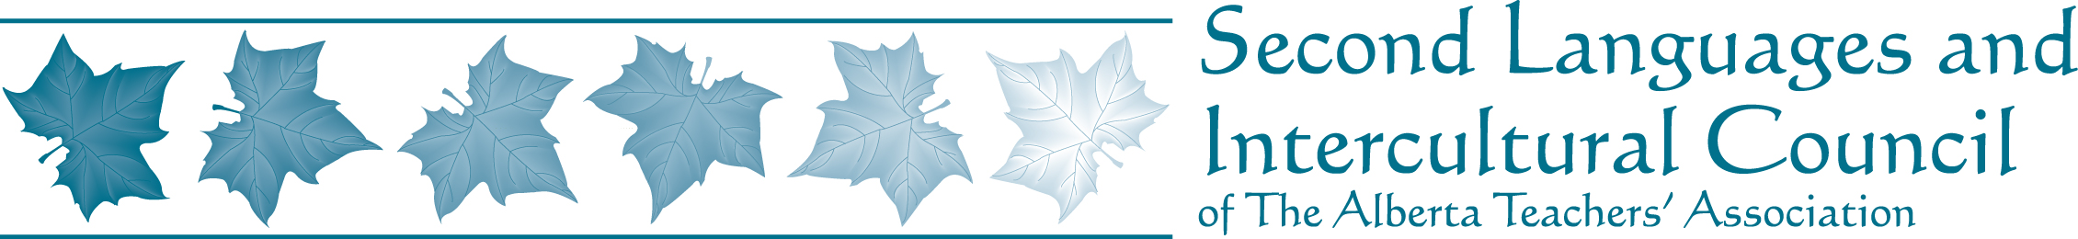

Alberta Spanish Teacher Association

February 20, 2010

Executive News
- Flyers for the Alberta Spanish Teachers Association printed and handed out at the 2nd Languages Matter PD Day
Pending Plans:
- Biography posted on the SLIC and ATA website by March 30, 2010
- Spanish teachers to be contacted with letter of introduction and survey in order to compile information about active members by March 30, 2010

PD and other events
Current
- Free Spanish Cinema series held at U of A on the first Tuesday of every month until June, 2010
- Free Taller de Flamenco held weekly by Desiree Soriano and Ana Martinez until end of March, 2010
- Spanish Teachers Conversation Group is meeting once a month at IISLE until June, 2010
- On Feb. 19, 2010, the 2nd Languages Matter PD took place. Topics focused on language learning and those specific to Spanish included:
-Musicando en Español con Jorge Vargas (whose students’ performance of Spanish guitar was televised on Shaw cable in February)
-CEFR + Program of Studies + Tasks = Student Engagement! Presented by Zulema López de Neale and Jennifer Francis, with examples in Spanish and French
- AVE licenses available through IISLE for piloting with students and teachers
Upcoming
- GETCA Teachers’ Convention on February 25th and 26th. Sessions related to Spanish will include Cuban Music and Dance
- Registration for the DELE is open and available to students and teachers. Tests will be administered in May, 2010. The new A2 level will be available at this time
- Registration for the 2010 Cursos de Verano in Spain is open until the end of the February. Teachers can apply for scholarships until the end of the February
- Teachers may apply for the SLIC and CASLT scholarships
- In April, the IISLE will host a series of PD addressing the implementation of Bilingual Performance Tasks from March 2 –April 13, 2010

